



**Name: Muhammad Danyal**

**Reg.No: 4304-BSSE-F21-B**

**Submitted to: Sir Shakir Rasheed khan khattak**

**Assignment No : 2**

**Q1: Describe the Waterfall Model and list the stages of Waterfall Model for software development and list three of its advantages and disadvantages?**

**WATERFALL MODEL :**  The waterfall model is a classical model used in system development life cycle to create a system with a linear and sequential approach. It is termed as waterfall because the model develops systematically from one phase to another in a downward fashion.

**Stages of Waterfall Model:**

1. Requirements analysis
2. System and Software Design
3. Implementation(coding) and unit testing
4. Integration and system testing
5. Deployment
6. Maintenance

**Advantages:**

* This model is simple and easy to understand and use.
* It is easy to manage due to the rigidity of the model – each phase has specific deliverables and a review process.
* In this model phases are processed and completed one at a time. Phases do not overlap.
* Waterfall model works well for smaller projects where requirements are clearly defined and very well understood.

**Disadvantages:**

* High amounts of risk and uncertainty.
* Not a good model for complex and object-oriented projects.
* Once an application is in the [**testing**](http://tryqa.com/what-is-a-software-testing/) stage, it is very difficult to go back and change something that was not well-thought out in the concept stage.
* Not suitable for the projects where requirements are at a moderate to high risk of changing.

**Q2: List the stages of the software development lifecycle (SDLC). Describe each stage each?**

1. **Planning**

In the Planning phase, project leaders evaluate the terms of the project. This includes calculating labor and material costs, creating a timetable with target goals, and creating the project’s teams and leadership structure.Planning should clearly define the scope and purpose of the application

**2. Define Requirements**

Defining requirements is considered part of planning to determine what the application is supposed to do and its requirements.Requirements also include defining the resources needed to build the project.

**3. System Design**

Based on the requirements in SRS desired features and operation in detail are

Specified and documented in a DDS (Design Document Specification)

Including Screen layouts, Business rules, Process diagrams and other

Documentation

**4. Software Development**

In this stage of SDLC the actual development starts and the product is built.

The programming code is generated as per DDS during this stage.

**5. Testing**

This stage refers to the testing of the product where products defects are

reported, tracked, fixed and retested, until the product reaches the quality

standards defined in the SRS.

**6. Deployment**

Once the product is tested and ready to be deployed it is released formally in

the appropriate market. (i.e. where the software is put into production and runs

actual business)

1. **Operations and Maintenance**

In this phase, users discover bugs that weren’t found during testing. These errors need to be resolved, which can spawn new development cycles.In addition to bug fixes, models like Iterative development plan additional features in future releases. For each new release, a new Development Cycle can be launched.

**Q3: Using a natural language:**

* Librarian can record a book loan.
* Every book has an ISBN number and may have several copies and copy number.
* When a borrower ask for a book for his corresponding ISBN number librarian will check if its available or not if not available than librarian will give due date of the book to the borrower.
* If available then give the borrower the self no and due date of upto 2 weeks and record a book loan against that borrower number.
* If borrower return the book than change the record and select that borrower return book on that date and make the book available for other borrowers.

**Q4: Draw Use Case Diagram and Domain Model for the problem mentioned in Q3?**

**Use case:**

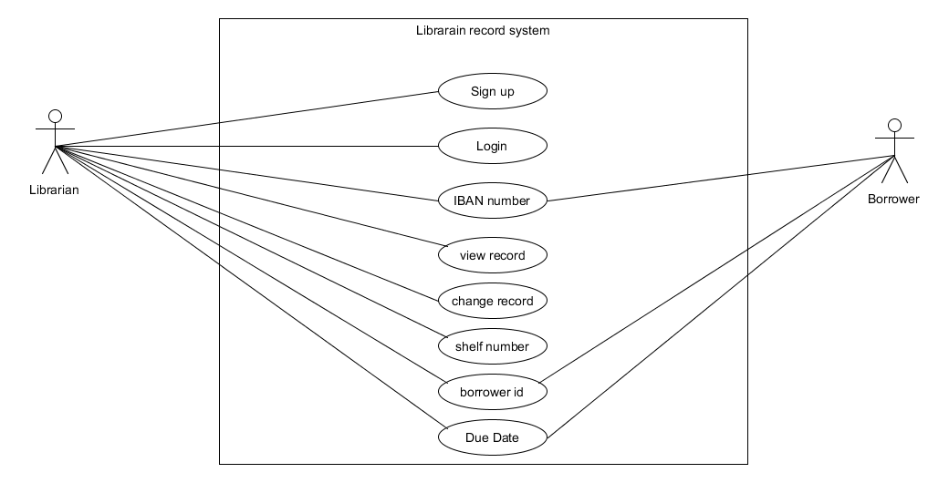

**Domain Model:**

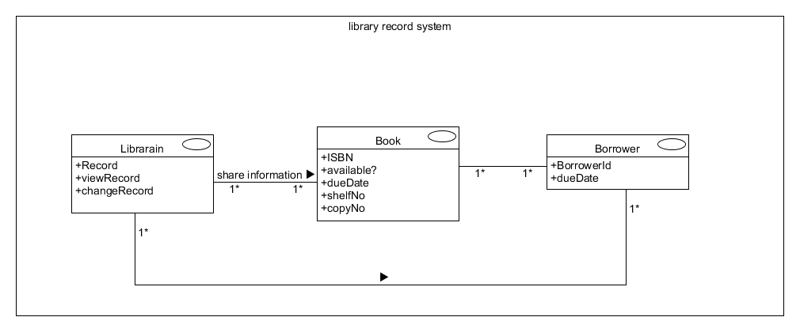

**Q5: Write the Non-functional requirements for the following two projects?**

1. **Bike racing game:**

* Performance
* Usability
* Maintainability
* Reliability
* Portability
* Supportability
* Adaptability

1. **Online Banking system:**

* Security
* Performance
* Usability
* Adaptability
* Reliability
* Confidentiality
* Operability
* Recoverability
* Traceability
* Visibility